The Rules
2. No smoking in the theater (If you're just flaming, join cast).
2. This is an audience participation movie...
2. Do not throw anything at the stage, the screen, or the thespians.
2. If you have a penis, use the men's room. If you have a vagina, use the ladies room. If you've got both, piss on Wade.
2. No double sitting in the seats.
2. Don't fuck up our costumes. We WILL shank you.
2. This is an Rated-R movie. That means, if you're easily offended, we've got five words for you: Get The Fuck Out, Bitch.
Buy This Stuff
TP rolls $0.50
Buttons $1.00
Prop Kits $1.00
Bumper stickers $1.50
T-shirts *coming next week!!!* $10.00
Pic of the week
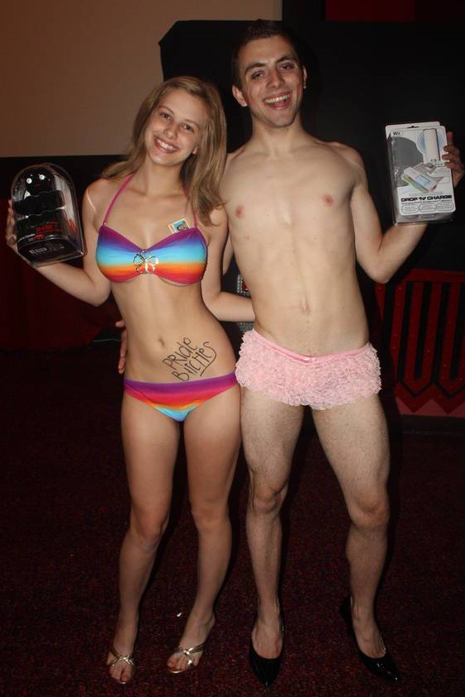
Our April Lingerie Night winners, MacKenzie and Trevor, show off their prizes
...and much, much more...
at last week's show!!

Regency South Coast Village Theater
c/o Midnight Insanity
1561 Sunflower Avenue
Santa Ana, CA 92704
www.midnightinsanity.org

© Copyright Midnight Insanity Entertainment 1988-2011 and beyond

The Rocky Horrible Picture Show!!!
Presented by
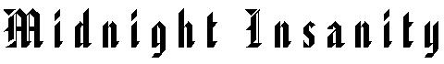

05/07/2011



